National Liaison Officers Network of ENISA has first meeting in 2019

ENISA today hosted the first meeting in 2019 of its National Liaison Officers Network (NLO) in Athens, Greece.

Published on January 29, 2019

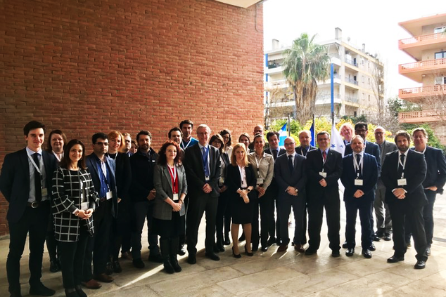

Tagged with

* [National Liaison Officer (NLO)](https://www.enisa.europa.eu/search?Subject%3Alist=National%20Liaison%20Officer%20%28NLO%29)

The meeting was chaired by Steve Purser, ENISA’s Head of Core Operations Department. Mr. Purser opened the meeting by addressing the latest developments in the life of the Agency – the new mandate brought forward by the proposed cybersecurity act, and the proposal to make the NLO a statutory body of ENISA.

The NLO initiated constructive discussions on its contribution to the Work Programme of the Agency for 2019, and representatives of the NLO Group provided input on national developments.

ENISA experts updated the NLO on the preparations for the Agency’s flagship projects: the European Cybersecurity Challenge and the European Cybersecurity Month. Training in information security management, the NISD cooperation group, and certification were also discussed.

The NLO Group acts as a liaison between ENISA, the community of network and information security experts and relevant organisations in the EU Member States. They facilitate ENISA’s work in their respective country.

The NLO network is composed of one representative from each EU and EEA Member States. A representative from the European Commission and one from the Council of the European Union are also part of the network.